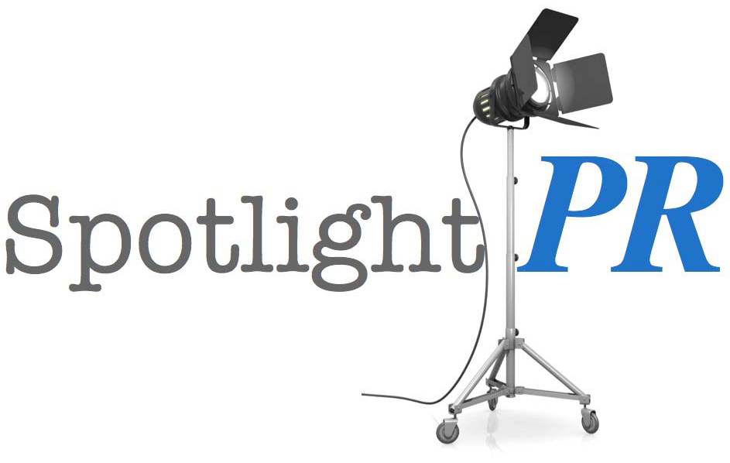
PR STRATEGY SESSION
Info Sheet

________________________________________________________________________________________
Directions: please answer what you can below. Then, email your answers at least 48 hours in advance of your scheduled call to: Info@SpotlightPRcompany.com
________________________________________________________________________________________

name:
phone:
email:
social accounts:

About Your GOALS:
- What’s your overall goal – long term and short term?
- What’s your PR goal – long term and short term?
- What’s the biggest issue you would like to concentrate on during our session?
- Are you more interested in gaining fans or media attention?
- Have you previously or are you currently implementing any PR outreach? If yes, what specifically were/are you doing…and what were/are the results?
- Are you actively promoting using social media? If yes, what specifically are you doing…and what has been the results?
- What’s been your biggest challenge when incorporating PR into your strategy?
- Is there a specific project(s) coming up that you want to focus on? If yes, fill out “PROJECT” section below.
- How much time do you have to devote to your PR: daily/weekly?
- Are you planning to hire outside PR help? If yes, what is your PR budget?

About YOU - General Info:
- Your industry name.
- Previous credits, including film, television, Broadway theater, webisodes, etc.
- Future projects you’re working on (acting in, producing, directing, etc.); these can be either jobs you’ve been hired for or projects you are creating yourself.
- Any awards or accolades you’ve won.
- Where did you grow up?
- Who’s your representation?
- What’s the closest big city to which you live? How long have you been there?
- Any unique or interesting hobbies.
- Have you done any interviews or had any articles written about you previously?

About Your SOCIAL MEDIA:
- What’s your social media goals - long-term and short-term?
- Are you actively promoting using social media and for how long?
- What platforms are you on currently…and are you looking to add any more?
- What’s been your biggest challenge when it comes to social media?
- Any fears about using social media?
- How much time do you have to devote to your social media: daily/weekly?
- Do you post images…how often?

About Your PROJECT:
- Name of your project and what was your participation in it?
- Dates your project will premiere/air and where?
- Any network or studio affiliation?
- What’s the genre (comedy, drama, action, thriller, etc)?
- Type of project (short, feature, webisode, etc)? Running time?
- How would you describe this project (in a sentence or two)?
- Dates you shot it, where shot, how long you worked on the project.
- Brief summary of the plot of the project.
- Known industry people you worked with on the project (actors, directors, producers or anyone else that is well known in the industry).
- Any story or interesting detail about the shoot, the script, how you got it together, secured a particular person or funding, etc.
- Do you have any still photos from this project to use?

Additional Stuff to Send:
- Your biography (if you have one).
- Any links or websites to view your work online.

